# Logo sketches analysis

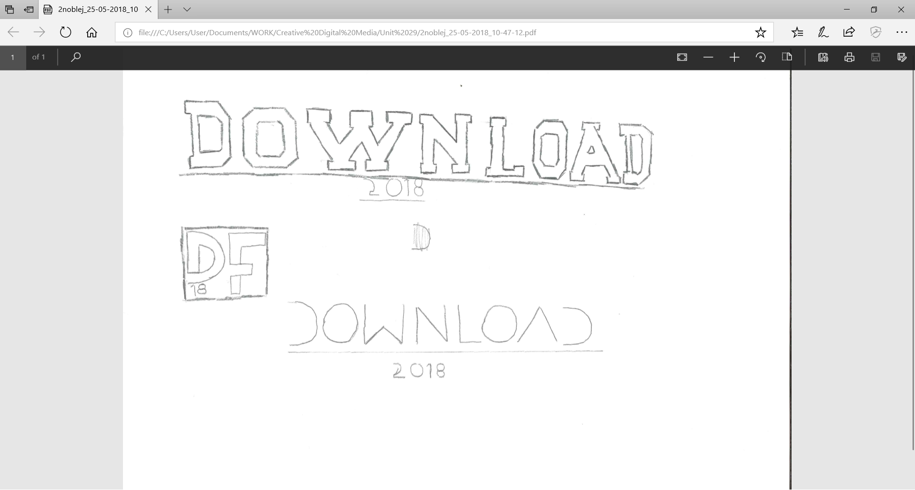Pros:

* Clear
* Visually pleasing
* Would be better as an icon for the tab of a webpage rather than the main logo

Cons:

* Unclear as to what the logo is for
* Too small for a main logo
* Doesn’t suit the target audience

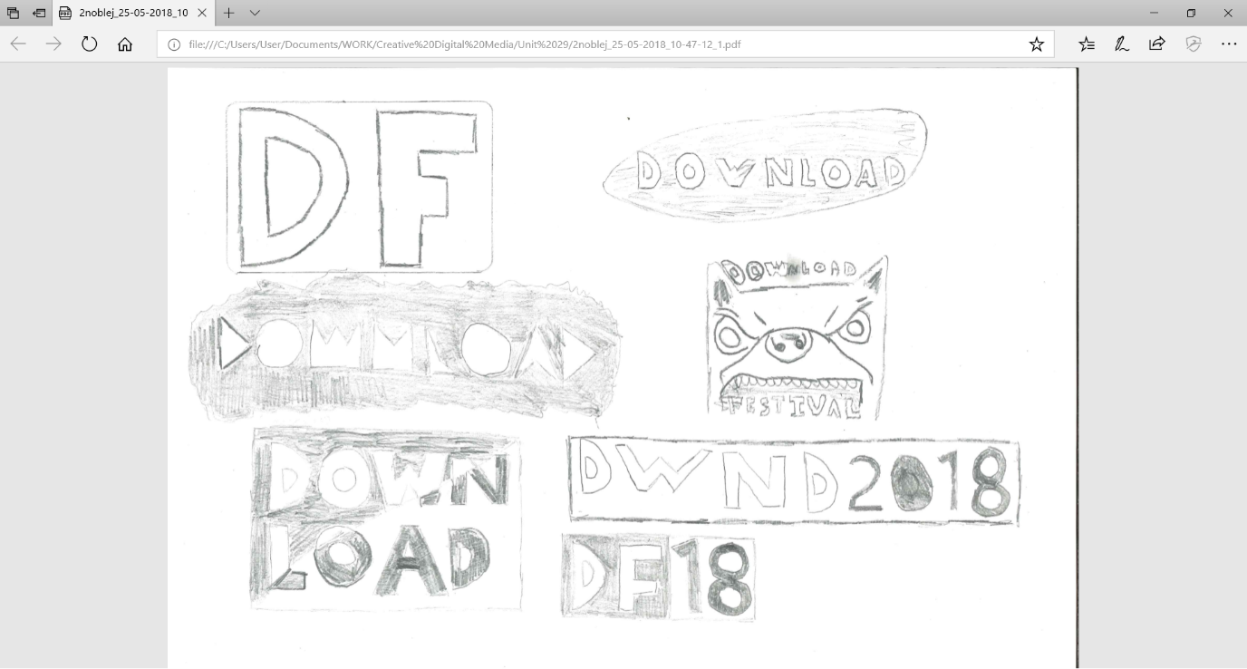

Pros:

* Suits the target audience better
* Looks unique

Cons:

* Could be hard to read due to unclear lettering
* Would be hard to print, and it would be hard to make other graphics suit the same style

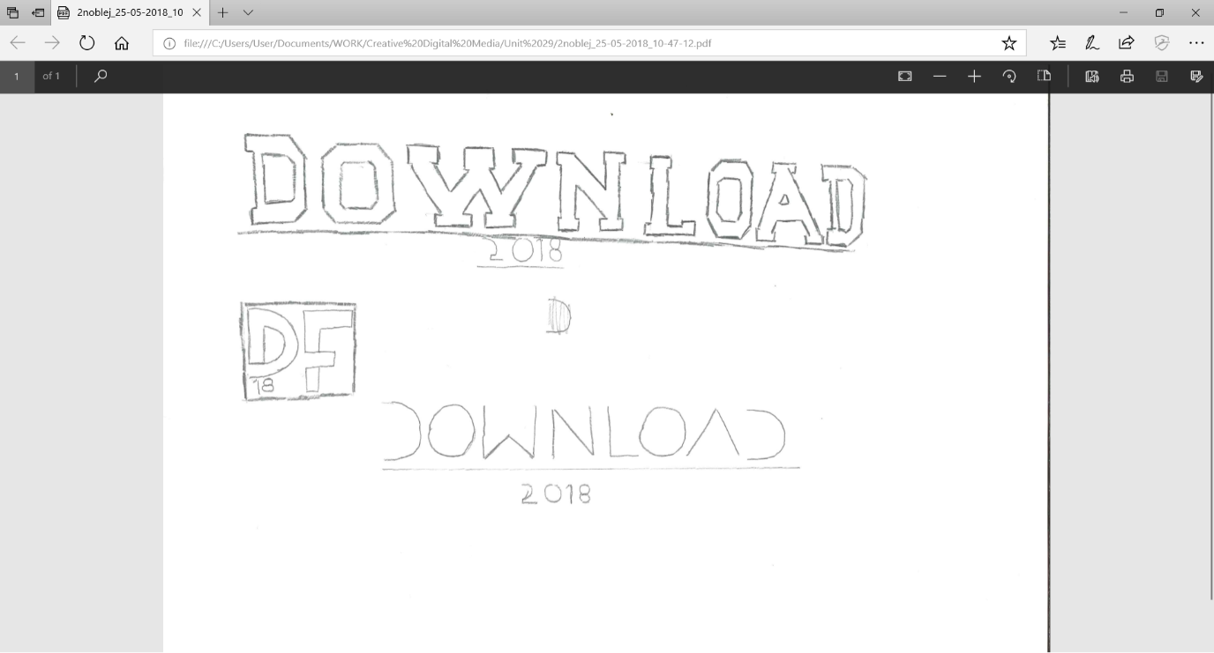

Pros:

* Clear to read
* Although the lettering is stylised, it is still easy to make out the individual letters
* Tells the reader what year the festival will be

Cons:

* Doesn’t suit the target audience very well, as the festival is suited towards fans of metal and rock, which could be considered more messy due to the improvising that takes place during live events. The tidy nature of this font doesn’t suit the music very well.

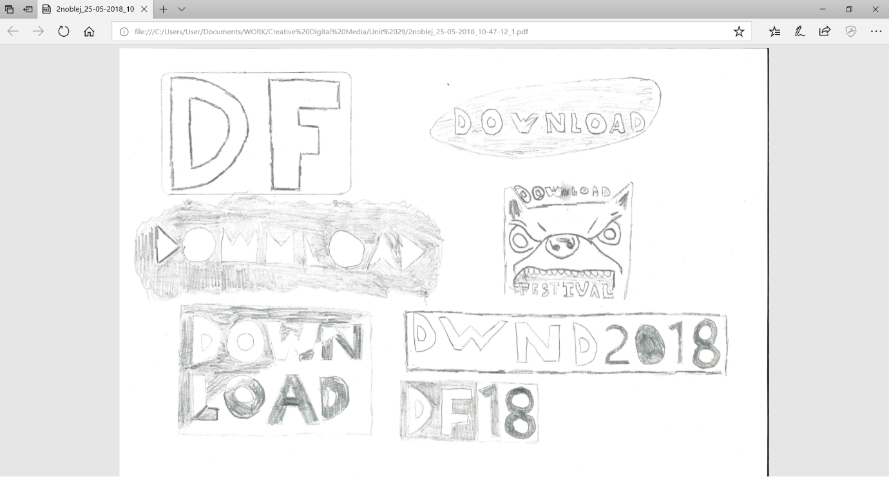

Pros:

* Visually appealing which could draw the attention of someone walking past it or seeing it on the internet.
* Clear to read due to bold lettering

Cons:

* Not having the word all on one line might make it unclear to the reader as to what the festival is called
* The white element would have to have some sort of boarder otherwise it wouldn’t stand out on white backgrounds, which would make the logo look worse.



Pros:

* The logo looks visually appealing
* Suites the target audience as the angry dog could represent the angry nature of some of the songs played at the festival

Cons:

* The logo is too similar to the current logo design for the festival

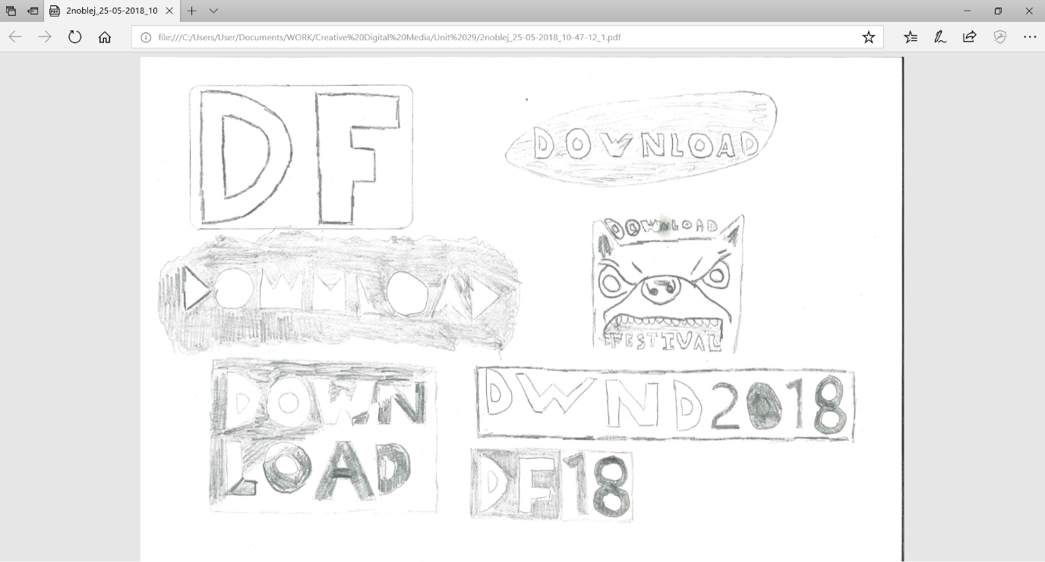

Pros:

* Simplistic and easy to make
* Would work well as a logo for a website

Cons:

* Too boring for a main logo for a festival, and wouldn’t draw anyone’s gaze.

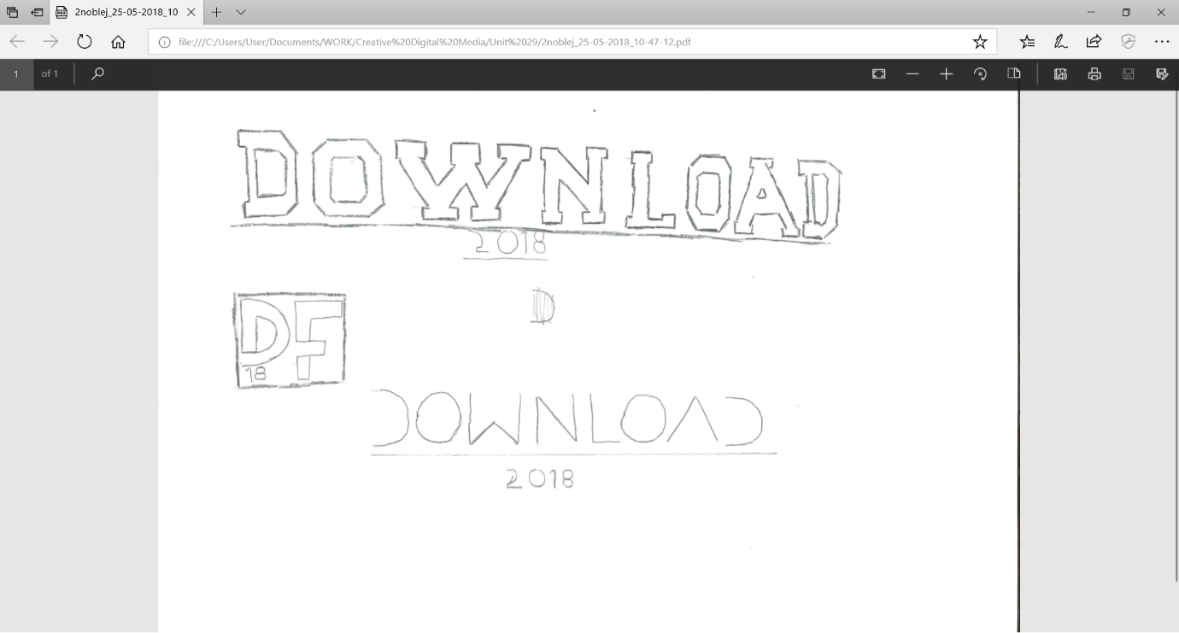

Pros:

* Clear to read meaning people will be able to read what it says
* Says what year the festival will be in, although saying the full date would be better
* Would work well for a logo as its large and draws attention to itself

Cons:

* it’s a bit too boring for a logo, and although the boldness of it draws attention to itself, the logo itself isn’t very interesting.



Pros:

* the simplified wording makes the name able to fit onto a smaller logo, which makes it more versatile

cons:

* its unclear what the word says unless you already knew it was the download festival, which makes it somewhat useless as a logo.

Personally, I think the second logo is the best choice, as it looks good and suits the target audience much better than any of the others. Although I think it would be quite hard to implement, the extra effort would go along way in making the festival look better. the logo could also be made with a different font, which would also look quite good.